**ASSIGNMENT 5**

1. **What will be the output of 3 + 4 ** 6 - 9 * 10 / 2?**

**Ans: 4054.0**

1. **Count the number of vowels present in a string.**

**Code:**

string=input("Please enter a String: ")

count=0

for i in range(0,len(string)):

if(string[i]=='a' or string[i]=='e' or string[i]=='i' or string[i]=='o' or string[i]=='u'):

count=count+1

print("\nThe number of vowels in given string are: ",count)

**Output:**

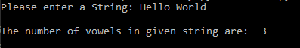

1. **Find out the area of triangle, take base and length from user.**

**Code:**

base=float(input("Please enter the Base: "))

height=float(input("\nPlease enter the height: "))

area=0.5*base*height

print("\nThe area of triangle with Base: "+str(base)+" and Height: "+str(height)+" is: "+str(area))

**Output:**

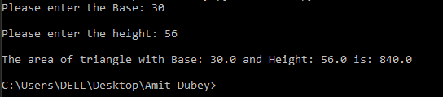

1. **Print the Calendar on the terminal. Ask year as input from user.**

**Code:**

def make_calendar(yyyy, sDay):

posStart = week_days.index(sDay)

if is_leap(yyyy):

calender[1] = ('Feburary', range(1, 29 + 1))

for mm, days in calender:

print('{0} {1}'.format(mm, yyyy).center(20, ' '))

print(''.join(['{0:<3}'.format(w) for w in week_days]))

print('{0:<3}'.format('')*posStart, end='')

for day in days:

print('{0:<3}'.format(day), end='')

posStart += 1

if posStart == 7:

print()

posStart = 0

print('\n')

def is_leap(yyyy):

if yyyy % 4 == 0:

if yyyy % 100 == 0:

if yyyy % 400 == 0:

return True

else:

return False

else:

return True

else:

return False

calender = [('January', range(1, 31 + 1)),

('Feburary', range(1, 28 + 1)),

('March', range(1, 31 + 1)),

('April', range(1, 30 + 1)),

('May', range(1, 31 + 1)),

('June', range(1, 30 + 1)),

('July', range(1, 31 + 1)),

('August', range(1, 31 + 1)),

('September', range(1, 30 + 1)),

('October', range(1, 31 + 1)),

('November', range(1, 30 + 1)),

('December', range(1, 31 + 1))]

week_days = ['Mo', 'Tu', 'We', 'Th', 'Fr', 'Sa', 'Su']

yr=int(input("Please enter the year: "))

startday=input('Please enter the startting day of the year i.e Mo,Tu,We,Th,Fr,Sa,Su: ')

make_calendar(yr,startday)

**Output:**

